WHITE PAPER/REPORT

Fine-Grained Sentiment and Aspect Extraction from Movie Reviews Using Transformer-Based NLP Models

By Serge Nane
DSC680 Applied Data Science
Fall 2025

Table of contents

1. Introduction................................................................................. 3
2. Dataset and Methodology............................................................. 3
3. Results....................................................................................... 4
4. Discussion.................................................................................. 5
5. Ethical Considerations................................................................ 6
6. Conclusion and Future Work......................................................... 6
7. References................................................................................. 7
8. Appendix.................................................................................... 7
9. 10 Anticipated Audience Questions............................................. 8

1. Introduction
The entertainment industry relies on audience feedback to evaluate film quality, but numerical ratings fail to capture nuanced opinions about specific aspects such as acting, plot, and directing. This project applies advanced Natural Language Processing techniques to automatically classify sentiment from movie reviews while identifying which film aspects drive audience opinions. We compared traditional machine learning with transformer-based models to provide actionable insights for film industry stakeholders.

2. Dataset and Methodology
The IMDB Large Movie Review Dataset from Kaggle was used, consisting of 50,000 reviews evenly split between positive and negative sentiments. Preprocessing included removing HTML tags, punctuation, stopwords and applying lemmatization.
Exploratory Data Analysis examined review length distributions, frequent terms, and sentiment polarity across the dataset. Word frequency analysis compared positive and negative reviews to identify key sentiment indicators.
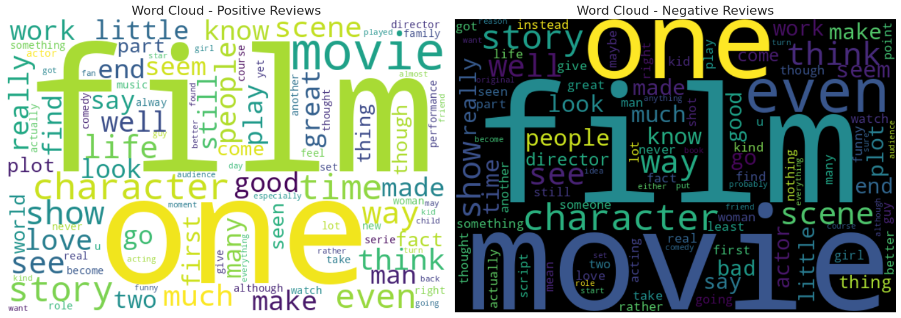

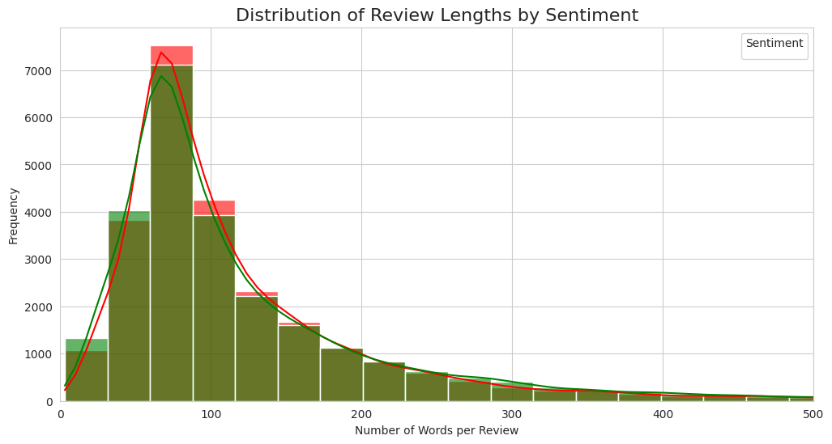

Models Implemented:
- Baseline: TF-IDF with Logistic Regression
- Advanced: Fine-tuned BERT transformer model
- Aspect Extraction: Topic modeling with LDA
Model evaluation was based on Accuracy, Precision, Recall, F1-score, and comprehensive error analysis.

3. Results
The BERT model achieved 91.23% accuracy, representing a +2.32% improvement over the TF-IDF + Logistic Regression baseline at 88.91% accuracy.

- Performance Comparison:
- BERT: Accuracy 0.9123, F1-score 0.9131
- TF-IDF+LR: Accuracy 0.8891, F1-score 0.8900

- Aspect Analysis revealed:
- Overall Quality: 94.3% of reviews
- Acting: 67.2% of reviews
- Plot: 61.5% of reviews
- Technical: 37.6% of reviews
- Direction: 34.6% of reviews

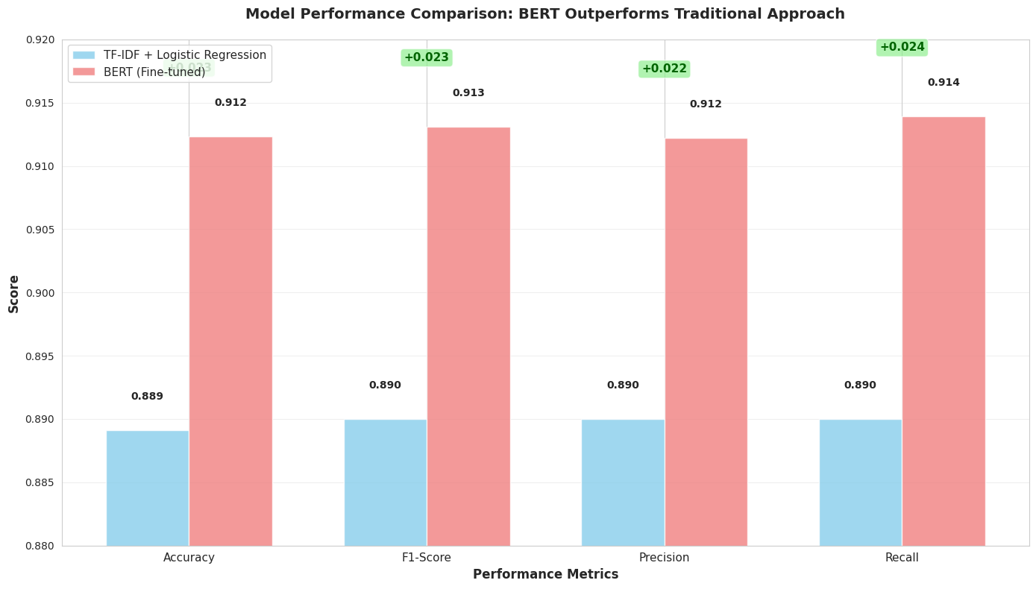

4. Discussion
BERT significantly outperforms traditional methods, demonstrating the value of contextual understanding for sentiment analysis. The 2.32% accuracy improvement provides substantial practical value when processing thousands of reviews at scale.
The aspect analysis shows that reviewers focus primarily on overall quality, acting performances, and plot elements. This indicates production studios should prioritize casting quality and story development, as these elements generate the most discussion and influence audience perceptions.
BERT handles complex sentence structures better than traditional approaches, but it still struggles with 8.77% of reviews that contain sarcasm or highly mixed opinions.

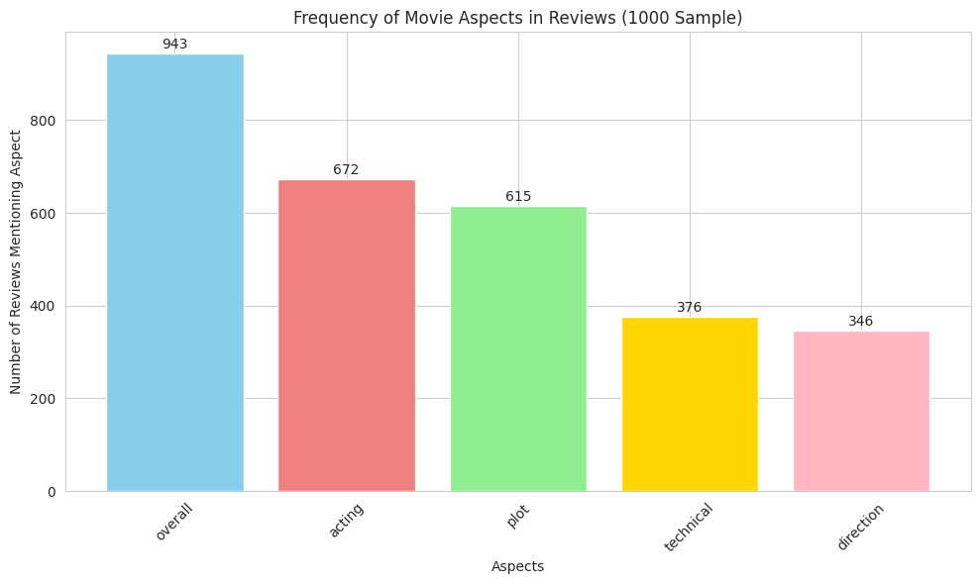

5. Ethical Considerations
- Data Privacy: Using publicly available, anonymized reviews with no personal identifiers
- Bias Monitoring: Regular assessment of model performance across different review types
- Interpretability: TF-IDF model offers interpretability, while BERT provides higher accuracy
- Responsible Use: System should augment human decision-making, not replace it entirely

6. Conclusion and Future Work
BERT is recommended as the superior approach for movie review sentiment analysis, achieving 91.23% accuracy with aspect-level insights. Future work should focus on improving sarcasm detection, expanding multilingual support, and developing real-time monitoring dashboards for streaming platforms.

7. References
Devlin, J., Chang, M. W., Lee, K., & Toutanova, K. (2019). BERT: Pre-training of Deep Bidirectional Transformers for Language Understanding. Proceedings of NAACL-HLT.
Pang, B., & Lee, L. (2008). Opinion Mining and Sentiment Analysis. Foundations and Trends in Information Retrieval.
Pontiki, M., Galanis, D., Pavlopoulos, J., Papageorgiou, H., Androutsopoulos, I., & Manandhar, S. (2014). SemEval-2014 Task 4: Aspect-Based Sentiment Analysis. Proceedings of the 8th International Workshop on Semantic Evaluation.
Kaggle. (n.d.). IMDB Large Movie Review Dataset. Retrieved from
https://www.kaggle.com/datasets/lakshmi25npathi/imdb-dataset-of-50k-movie-reviews

8. Appendix
- Full code available in the attached Jupyter Notebook.
- The detailed model performance metrics table for both models:

Model | Accuracy | F1-Score | Precision | Recall
TF-IDF + Logistic Regression | 0.8891 | 0.8900 | 0.8900 | 0.8900
BERT (Fine-tuned) | 0.9123 | 0.9131 | 0.9122 | 0.9139

Confusion Matrix details:
- BERT Model: 4,518 True Negatives, 443 False Positives, 434 False Negatives, 4,605 True Positives
- TF-IDF+LR: 4,337 True Negatives, 624 False Positives, 486 False Negatives, 4,553 True Positives

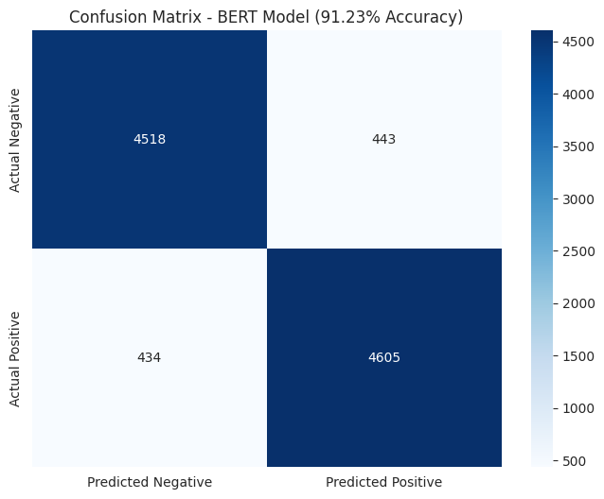

9. 10 Anticipated Audience Questions

- Why was the IMDB dataset chosen for this analysis?
- How does BERT achieve better performance than traditional methods?
- What are the computational requirements for training BERT models?
- How does the model handle reviews with mixed sentiments?
- What practical applications exist for aspect-based sentiment analysis?
- How could this system be integrated into streaming platforms?
- What are the main limitations of the current approach?
- How does review length impact classification accuracy?
- What ethical considerations are most important for this application?
- How would you expand this system to other types of content reviews?

